DEVOPS LABS

Requirement :

1. <https://www.jetbrains.com/idea/>
2. Maven : <https://maven.apache.org/download.cgi>?.

Configuration :

environment variable :

MAVEN_HOME

C:\Users\arjun\Downloads\apache-maven-3.9.9-bin (1)\apache-maven-3.9.9

path

C:\Users\arjun\Downloads\apache-maven-3.9.9-bin (1)\apache-maven-3.9.9\bin

Installation DONE :

Maven version : 3.9.9

JAVA Version : 21.0.7

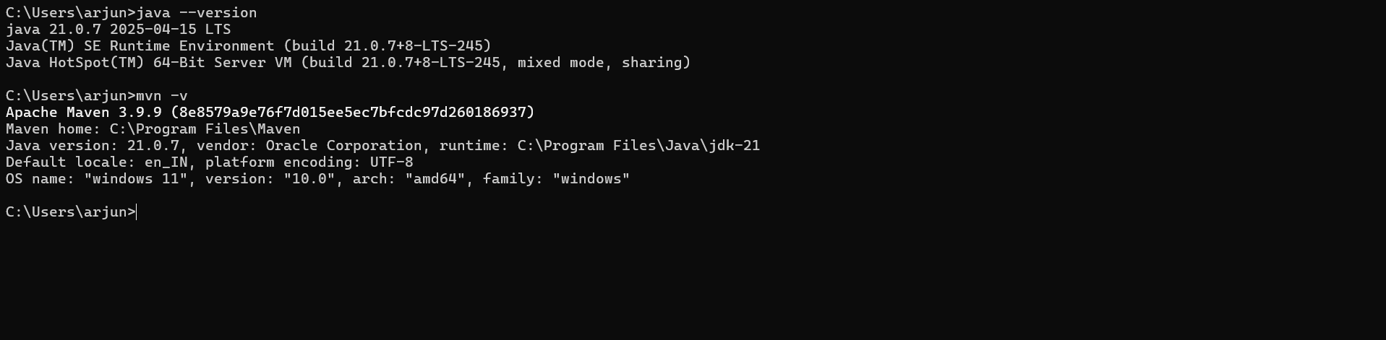

1. Github :
2. Project Skeleton : <https://start.spring.io/index.html>

Spring skeleton option select :

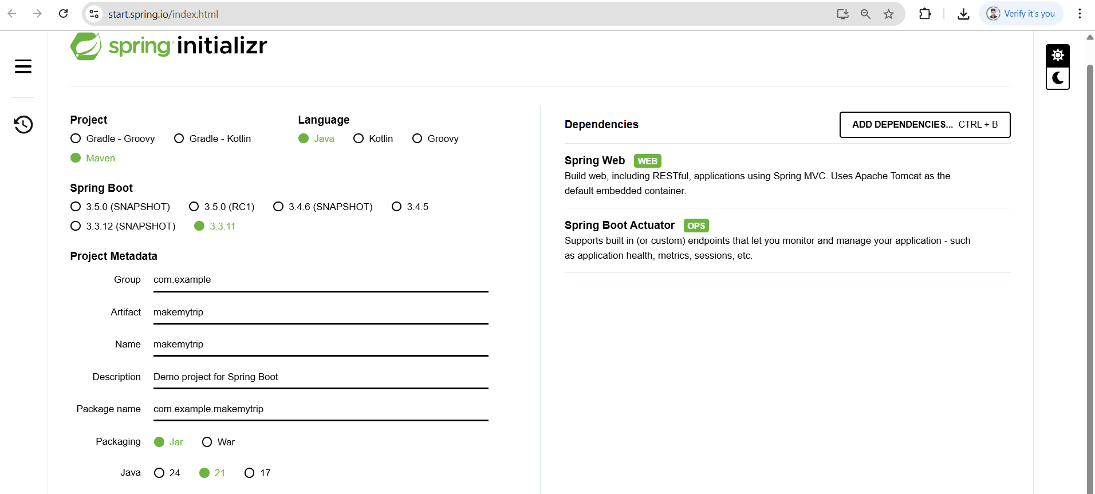

Git branching Strategies

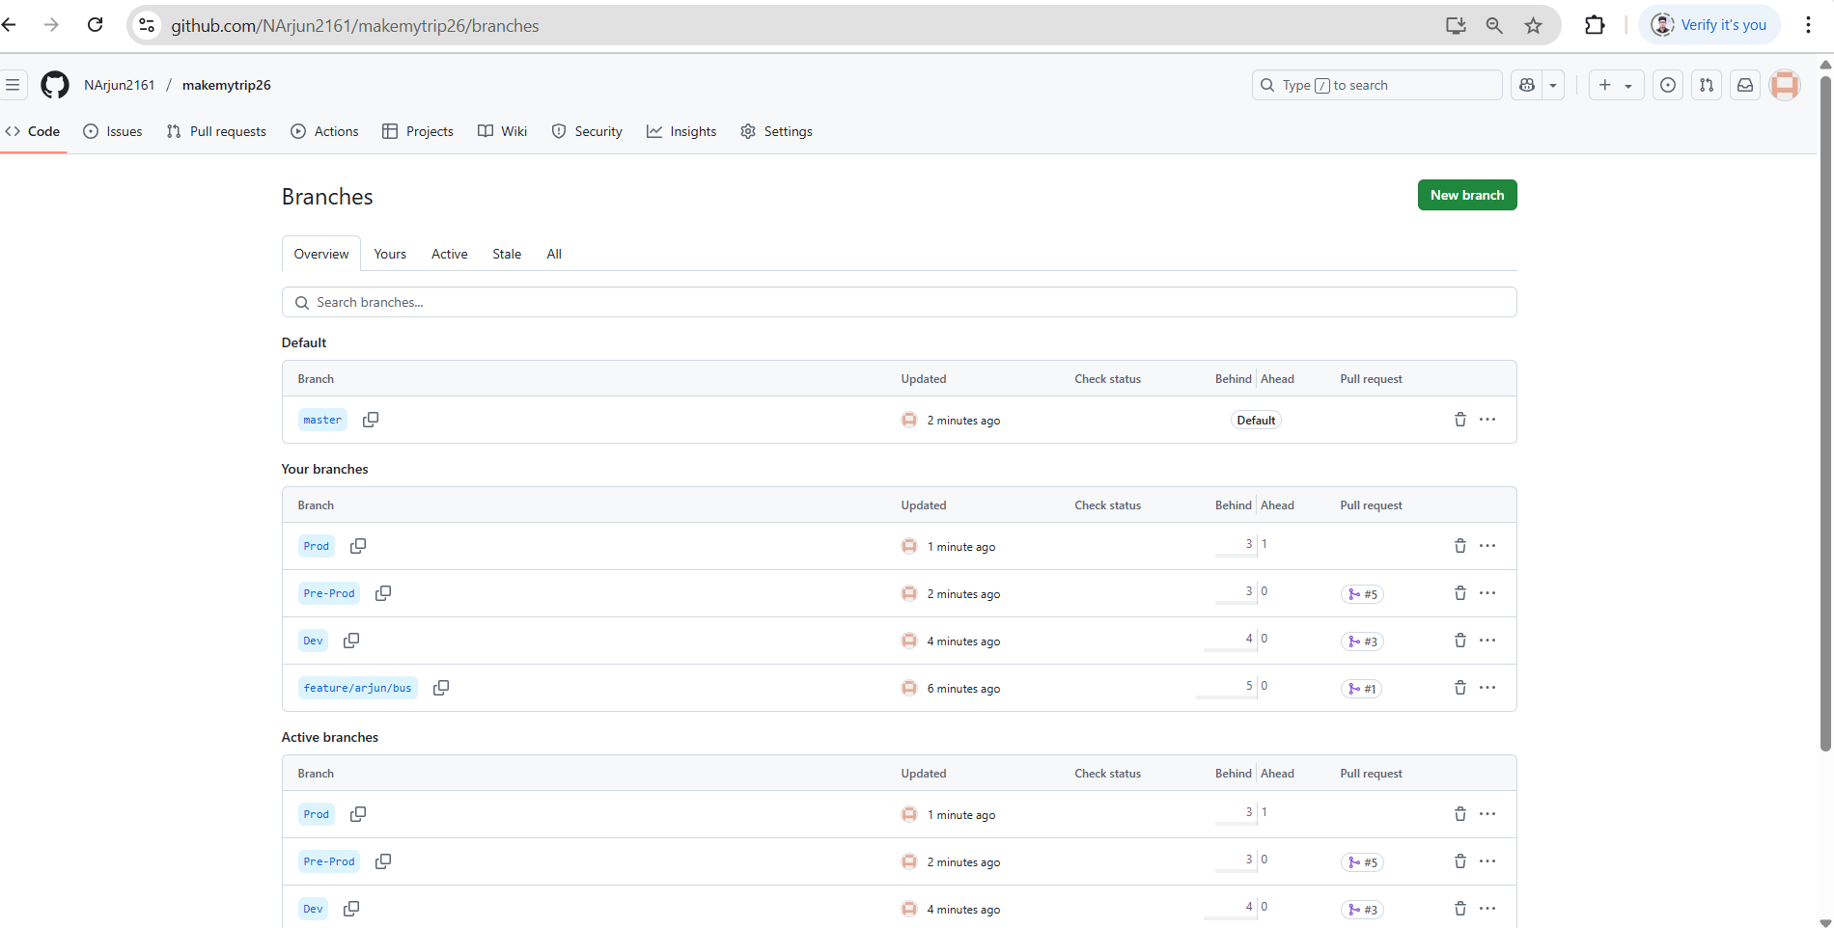

Project

